Dear all,

we are happy to welcome you soon to our GROWL course „Mental Infrastructures and Degrowth Transformation“ in Leipzig.

As the seminar includes a participation in the „Fourth International Degrowth Conference“, it is split up into two main sections:

A. September, 2nd – September 6th: Degrowth Conference in Leipzig (introduction into „Degrowth“ and „Mental Infrastructures“)

September 7th: Free day

B. September, 8th – September 11th: Mental Infrastructures and Degrowth Transformation in Sehlis (in close proxitmity to Leipzig)
+ Train-the-Trainer-Module (Sept. 11th)

In the following we would like to provide you with details on the seminar and the conference, including questions of directions, accomodation and food.

A) Degrowth Conference (Leipzig)

The principal location of the conference is the main building of University of Leipzig:

Universität Leipzig, Augustusplatz 10, 04109 Leipzig

Detailed information on the conference including a comprehensive program and directions is accessible through the website of the conference: http://leipzig.degrowth.org/en/

Very important: Our first meeting as GROWL-group will take place on

Tuesday, September 2nd, 2 pm

Room 211 in the „Seminargebäude“ of the University

Address: Universitätsstraße 1, 04109 Leipzig

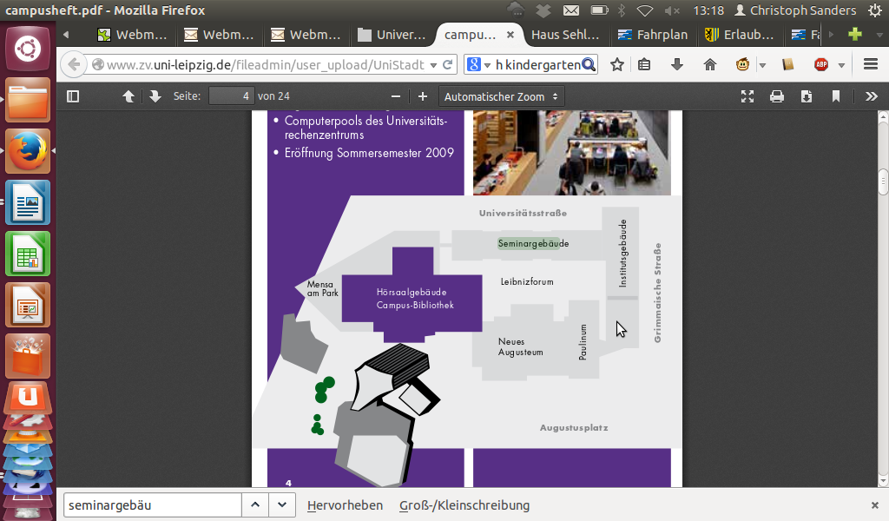

Camping Site

After this meeting we will go together to the campsite of the conference where most of you will stay. Here the group will have a proper area for ourselves. We can stay on the site until the morning of September 8th – until we leave for Sehlis for the second part of seminar.

Feel free to check-in on the camping site before our first meeting – if you wish. Check-in opens at 11 am on Tuesday, September 2nd. You will find further details about your staying on the camping site, including directions, in the annex.

Please bring your own tents, sleeping bags and sleeping mats as we are unfortunately unable to provide them.

Food during the conference

During the conference food will be fully provided at lunch and dinner times. Please take care of your own breakfast during this time. During the GROWL course itself we will, of course, provide full board.

The topic of mental infrastructures on the conference

The conference serves as an introduction into the topic of degrowth in general and – more specifically – to mental infrastructures. For events which are introducing into degrowth, please check the program of the conference: http://programme.leipzig.degrowth.org/en/degrowth2014/public/schedule.
As registered participant of the conference you will also receive a booklet when you get to the conference.

For the topic of mental infrastructures, we compiled a list of respective conference events. You will find it in the annex.

B) Mental Infrastructures and Degrowth transformation

In the morning of Monday, September 8th, we meet for the second part of the seminar:

Where?
Haus Sehlis
Sehliser Str. 31
04425 Taucha

How to get there? See description in the annex

When? Between 10 am and 11 am

Accomodation and food in Sehlis

„Haus Sehlis“ has sufficient three-bed-bedrooms which we will share during our stay. Food will be fully provided by a feminist collective mostly preparing vegan but always vegetarian meals. They are exclusively using organic food.

Please get back to us as soon as you can if you have special needs in regard of food (such as allergies etc.)

In addition to tea and coffee, which is included in the food provision, we will organize additional beverages (soft drinks, beer etc.). We do not plan to introduce fixed prices but prefer donations.

Note that there is no Internet connection and no printer in the house.

Most of the GROWL seminar is covered by funds of the European Union. Therefore we can offer the course for free. We would still like to ask you for a donation if you have the possibility to contribute financially. This will help us to cover the rest of the costs and make more travels available for other participants. Please bring your donation in cash if you don't have a German bank account. People with German bank accounts can make a digital transfer after the course, of course.

Train the Trainers (TTT)

Each GROWL-course contains a TTT-module. This allows all interested participants to become a „Trainer for Degrowth“ themselves. The idea of TTT-modules is to reflect on degrowth methodologies and content used within the GROWL-context, to get to know training methods and tools for degrowth and to try them out personally.

The TTT module of the Leipzig course will take place on Thursday morning. Please let us know if you want to participate in it!

Requirements to become a TTT-trainer include:
1. Take part in at least two different GROWL courses, ideally one in the own country and one in another country.
2. Attend the TTT module on both courses
3. Between the first and the second course, prepare some house work connected wtih the TTT dimension. This home work consist of two parts:
- A. A written work (4-5 pages) concerning a specific topic of the degrowth debate and/or action. As part of it, the future trainer should describe how it proposes to present this topic to a certain audience/target group (of his choice) as a trainer.
- B. A written preparation of a fictive course programme that could be organized in the organizer's place of living.
4. This home work has to be published on the GROWL virtual community one month before the second course. It has to be orally presented (A & B) inside of the TTT module of this second course.
5. The assignment will be reviewed by other trainers online and during the course, by course organisers and participants. The proposal for certification of a "GROWL trainer" will be done by two assigned reviewers from the GROWL network, taking into account the community feedback. The results should be issued up to 1 month after the assignment presentation.

General Aspects

The entire seminar, including the conference, will be held in English language. If this makes you feel unconfortable at any point during or prior to the seminar, please get back to us.

Please be aware that we are interested in a respectful and cooperative seminar atmosphere. We try our best to enable it and would like to ask you to do the same. GROWL has an awareness team that will be present at the course and that we will presented to you at the beginning. If you feel uncomfortable with your role in the group and/or you need support in a conflict with another person, please don't hesitate to let them know.

As an interesting, inspiring and pleasant seminar is also depending on your contributions, it would be great if you would bring material regarding the topic of the seminar which we could share (books, movies and the like) and stuff which enriches our common free time (instruments, music etc.).

Documents in the annex

In the annex you will find the following documents which will complete this document:
- Seminar schedule
- Seminar details including a list of recommended literature
- List of events on mental infrastructures during the Degrowth-conference
- Information on the camping site (including directions and a plan of the site)
- Getting to „Haus Sehlis“

We are looking forward to the seminar and to welcome you all in Leipzig.

Best regards,

Kristina, Susanne, Thomas and Christoph

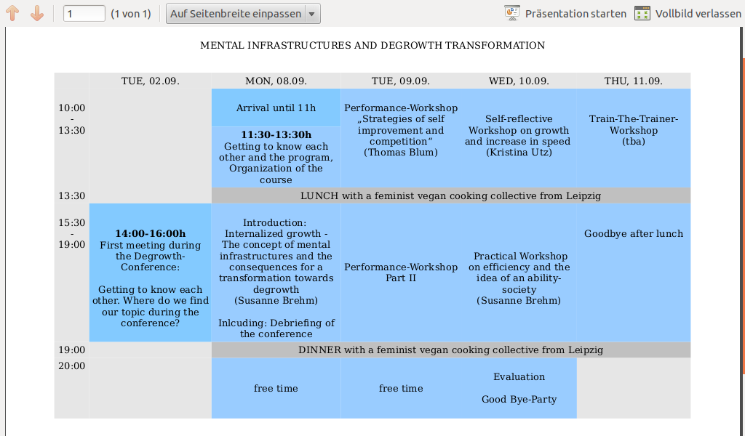

Module „Mental infrastructures and degrowth transformation“
Leipzig, 8-11th 2014

This is a more detailed description of what is going to happen in the most central „content“ parts of the MODULE on mental infrastructures. Of course, there will also be an introduction to the course, chances to meet and get to know each other, feedback mechnisms and so on...

A) Introduction
Monday afternoon // with Susanne Brehm

More knowledge about the ecological and social problems we are facing will not
necessarily help with the transition to a degrowth or postcarbon society. As psychological and sociological studies show, even a high conciousness for the social and ecological problems we are facing correlates very weakly with „appropriate“ behaviour in the daily lives of most people. Why is this so?
In this course, we will get to know and discuss the concept of „Mental infrastructures“ by the German social psychologist Harald Welzer, which has been widely received within the German degrowth debate. Welzer assumes that our usually growth-oriented thinking and acting is based on a number of cultural concepts he considers central and constitutive to the modern society. These concepts are part of our mental infrastructures, which means that they are so strongly internalized that we are hardly able to reflect them any more: future, individualization and biography, (indefinite) progress and self-improvement...
But we are not only shaped by these cultural concepts, we are also surrounded by "things" and structures that surround us NOW at present and shape our behaviour – by the way things are „usually“ done, by the way products are designed, sold, used and thrown away. By the habit to express personal growth in consumer acts or adventourous trips. By cities designed for increasing mobility...
Welzer proposes strategies how to deal with these infrastructures in order to be able to radically change our society. We will discuss the concept as well as the proposals for a change: Does the transformation to a degrowth society require a radical break with many or at least some of our mental and social infrastructures? What might be (positive and negative!) consequences? What strategies do we want to adopt as a movement? What does this mean for a political education for degrowth?

B) Performance-Workshop
Tuesday // with Thomas Blum

„Your potential, our passion“
Microsoft

Ideas of self-optimization and competition are essential mental infrastructures in a growth society and interrelate with each other. We want to develop ourselves, have a plan for our professional future and don't like mistakes. In a system based on competition, self- optimizing is an important strategy towards others regarding current and future developments. This correlates with an increasing role of economy in all fields of life. On the one hand imperatives of self-optimizing are brought to us for example by guidebooks such as self-management-guides or yoga-manuals. On the other hand we internalized the necessity of self-optimizing already in our childhood and - for instance in school – have also learned how to perform it. With this in mind we can find performative strategies of self-optimizing not only in theatre but also in our everyday life.

As experts for self-optimizing strategies in the Performance-Workshop we will deal playfully with internalized self-optimizing imperatives and with those we are confronted with in our daily lives. Based on body- and experience-orientated theatre methods we will try to create little irritations in these self-optimizing strategies.

C) Self-reflective Workshop on growth and increase in speed
Wednesday morning // with Kristina Utz

Growth and progress are concepts not only relevant in economic contexts; they shape our thoughts, feelings and actions. Personal progress and self-actualization are said to be necessary for a fulfilled and successful life. But how are these ideas linked to the capitalist economy we live in? And how does the paradigm of growth influence our biographies? And why is it so difficult to think outside the box of progress and growth?

Harald Welzer and Hartmut Rosa provide the theoretical background to link the concepts of growth and acceleration to our daily lives. Rosa's theory claims self-made acceleration of social structures is the main engine of economic growth. This phenomenon triggers acceleration in other areas, such as technology, and therefore provides the basis for economic growth. Welzer introduces us to the concept of mental infrastructures.

The workshop aims to connect Rosa's and Welzer's theory with our own biographies. How has acceleration and growth influenced our lives? What do our mental infrastructures look like? What are barriers that hinder us from thinking, feeling and acting differently? Could concepts like mindfulness-based training or solidarity help us change?

The workshop will combine theoretical input and practical exercises, most of which is based on self-reflective elements.

D) Practical Workshop: Experiencing (In-)Efficiency
Wednesday afternoon // with Susanne Brehm

Let's do this quick!

Especially within work structures we tend to have a big desire towards efficient structures and processes. A big part of scientific research is dedicated to find and test more efficient technology for the production and consumption of goods. But not only work, also the reproductive sphere as well as our free and leisure time are very much affected by our need or the desire to be more time and ressource efficient – be it induced by our „own“ wishes or by the circumstances and the desires of others we are confronted with. But at the same time the tendency towards ever more efficient technology and work
processes is one of the main drivers of the growth society and economy. The more efficient we are the more stuff we can produce, and the more stuff we can (and need to?) buy and consume. And it contributes to the acceleration of our livestyles – producing stress.

Efficiency therefore is - at least – ambivalent. In this workshop we want to experience efficient and inefficient, slow and fast forms of doing things – of preparing food, of constructing a chair, of repairing clothes... And we want to reflect coming from these experiences to a more general level: How does it feel to work this way? Is there a difference in resource input? How do I relate to the result of the process? What would be a good balance between the two extremes...?

About the trainers:

Susanne Brehm is part of the Konzeptwerk Neue Ökonomie, a thinktank for the social- ecological transformation based in Leipzig. She usually works as a trainer on degrowth and social-ecological transformation with youth groups and groups of young adults. She gives workshops and presentations, develops tools and methodologies for trainers and is at the moment involved in the organization of the IV. International Degrowth Conference.

Thomas Blum lives and works in Leipzig. As a theatre educator he dedicates himself to create performances with different groups of so called unprofessional actors. He is participating in several communities such as a community-supported-agriculture project where he loves to work in the fields. At the moment Thomas Blum is writing his doctoral thesis about political dimensions of theatre and education.

Kristina Utz is part of the Netzwerk Wachstumswende, a German degrowth and socio- ecological transition network. She designs and realizes educational projects around the topic with different groups and organizational backgrounds. As a psychologist, she is especially interested in the link with societal and individual transformation processes. How are capitalistic structures represented in our minds, and how is it possible to change these mental infrastructures? At the moment she is obtaining her Master’s degree in Berlin and besides degrowth, is interested in post-colonialism and migration, community and conflict transformation.

Literature:

Harald Welzer (2011): Mental infrastructures. How growth entered the world and our souls; http://www.boell.de/en/2013/12/09/mental-infrastructures-how-growth-entered-world-and-our-souls

Ulrich Bröckling (2012): The Subject in the Marketplace, the Subject as Marketplace Presentation at the Conference „The Marketization of Society: Economizing the Non- Economic“, University of Bremen, 01./02.06.2012 ;
www.mpifg.de/projects/marketization/downloads/Broeckling.pdf

Ulrich Bröckling (2007): Das unternehmerische Selbst. (engl. „The Enterprising Self -
Sociology of a Subjectification Form“)

Hartmut Rosa (2013): Social Acceleration – A New Theory of Modernity

Hartmut Rosa (2010): Alienation and Acceleration: Towards a Critical Theory of Late-
Modern Temporality

Christine Ax (2009): Die Könnensgesellschaft. Mit guter Arbeit aus der Krise.

Events on Mental Infrastructures on the Degrowth Conference

Camping Site Information

Dear delegate,
You registered for the camping site during the Degrowth Conference – here is some information:

1. The camping site will be at „agra Veranstaltungsgelände Leipzig“, the address is
Bornaische Straße 210, 04279 Leipzig.
You can reach this location by Tram 11 from Main Station Leipzig and the station Augustusplatz (location of the University of Leipzig and the main conference venue), direction Markkleeberg or Dölitz. The tram station is Dölitz Straßenbahnhof.
The map of the OpenStreetMap project is really good for this area and we recommend to use it for planning your trip by bicycle or car.
2. Check-in will open on Tuesday, Sep 2, 11am. The location shall be left by Sunday, Sep 7, until 4pm. If you want to stay until Monday, Sep 8, please inform Susann (camping@degrowth.de). Please send a message as well if you will come with your mobile home – this will allow better planning for us.
NOTE FROM THE GROWL-TEAM: It is not necessary to send a message to Susann. We will let her know how many persons will stay until Monday morning.

3. On the camping site, we will have toilets and showers – however, please be aware this is not a regular, commercial, professional camping site, but an area used for camping during festivals and other events.

4. Costs are calculated per person. Similar to our conference fees, we would like you to pay according to your possibilites, though the range is more narrow here: If everybody pays between the minimum of 40 Euro and 50 Euro, we will be able to cover the actual costs of the space. If you want to pay more than that, we will appreciate it.
Payment is possible only in cash at the check-in. Please have exact cash amount ready...

5. On the site, we want to take care for everything as a group – if you want to support us, please send an email to Susann (camping@degrowth.de)

In case of any questions, please do not hesitate to contact us. Please send us a note if you found another accomodation in the meantime and will not be at the camping site.

Looking forward to seeing you in Leipzig,
best regards -
Susann Reuter
for the Orga-Team/ WG Logistics

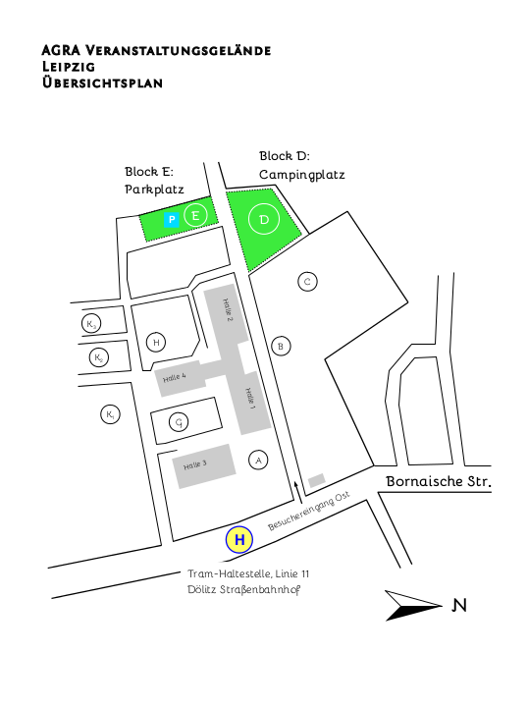
Plan of the Camping Site

Getting from the camping site to „Haus Sehlis“

Location of „Haus Sehlis“:

Sehliser Str. 31
04425 Taucha

Location of the campground:

Bornaische Straße 210
04279 Leipzig

Recommended connection:

9:02 from Leipzig, Dölitz, Straßenbahnhof; Tram line 11
9:08 arrival in Leipzig, S-Bahnhof Connewitz

Walk to the S-Bahn-Station (approx. 150m)

9:20 from Leipzig, S-Bahnhof Connewitz; S4
9:41 arrival in Taucha S-Bahnhof

Leave the station and walk to the bus station

9:51 from Taucha S-Bahnhof; Bus line 173
10:07 arrival in Panitzsch Kindergarten (11 stops after departure)
→ Someone will pick you up here

Walk to the Haus Sehlis → approx. 1,5 km;

For different connections check:

www.lvb.de; use Leipzig, Dölitz, Straßenbahnhof as a starting point and the address of Haus Sehlis as the point of arrival.

