Philosophical walk on education

Aim of the method:

Participants should be enabled to have a critical reflexion on learning methods, institutions and the neighbourhood as a learning place. They should exchange within intercultural und intergenerational context

Duration: 3 hours

Places:

Spot with overview over the city
Elderly people home

Short Discription:

Age-Group Walks

Participants are splitted into „age-groups“. If possible, an older person goes with a younger one ( at least one generation difference.
Participants are therefore asked to row up in an date-of-birth line, and than always one of the end of the line groups with on next to the middle and so on.
Participants are asked to exchange about the following questions:

1. How was your education experience in schools
2. What are your knowlegdes you base nowadays most on ( privat or in a job) and where did you learn about this knowledge
3. What did you learn in school, what in your neighbourhood surrounding?

Illich Text „Learning Webs“ Collective Reading

On a spot, from where you can easily see the whole town/village or a neighbourhood of a city, the group is splitted in sub-groups of 3-4 people, reading together the text, discussing and highlighting important points.

«In a previous chapter I discussed what is becoming a common complaint about schools, one that is reflected, for example, in the recent report of the Carnegie Commission: In school registered students submit to certified teachers in order to obtain certificates of their own; both are frustrated and both blame insufficient resources - money, time, or buildings - for their mutual frustration.
Such criticism leads many people to ask whether it is possible to conceive of a different style of learning. The same people, paradoxically, when pressed to specify how they acquired what they know and value, will readily admit that they learned it more often outside than inside school. Their knowledge of facts, their understanding of life and work came to them from friendship or love, while viewing TV, or while reading, from examples of peers or the challenge of a street encounter. Or they may have learned what they know through the apprenticeship ritual for admission to a street gang or the initiation to a hospital, newspaper city room, plumber's shop, or insurance office. The alternative to dependence on schools is not the use of public resources for some new device which "makes" people learn; rather it is the creation of a new style of educational relationship between man and his environment. To foster this style, attitudes toward growing up, the tools available for learning, and the quality and structure of daily life will have to change concurrently.
Attitudes are already changing. The proud dependence on school is gone. Consumer resistance increases in the knowledge industry. Many teachers and pupils, taxpayers and employers, economists and policemen would prefer not to depend any longer on schools. What prevents their frustration from shaping new institutions is a lack not only of imagination but frequently also of appropriate language and of enlightened self-interest. They cannot visualize either a deschooled society or educational institutions in a society which has disestablished school.»
Excerpt from Ivan Illich, 1970, „Deschooling Society“, chapter 6 on „Learning Webs“
Afterwards exchange in a circle about School, Critics on Institions and Learning possibilities in and for a degrowth society.

Notes taken during the course in Witzenhausen

when people say "a genius can cope with the school system" we should think of the fact that actually we're all genius (at least 98% of all small children) but school takes it from us...
school institution: no fair system, often a lot of "torture" involved
lessons are completely disconnected, too short, too fast and without time to take the information in and think critically about it
does the legal system give us opportunities not to go to school? --> very difficult in Germany
there are possibilities to choose kindergarden and freer schools
degrowth: many people have a lot of knowledge that they could share --> develop a different understanding of education? more relationship based? new ways of distribution? create own certification and ways of learning?
interesting: homeschoolers are often very well educated and are able to think in more creative and holistic ways
schools are still designed for industrialisation, for growth and don't encourage critical thinking at all, pupils just have to function

Discussion about Care of Eldery People

On the way to an eldery home ( in Witzenhausen Transition Town has a intergenerational garden project cooperation with one of these), a normative text is being distributed, talking about different age groups and marketing strategies.

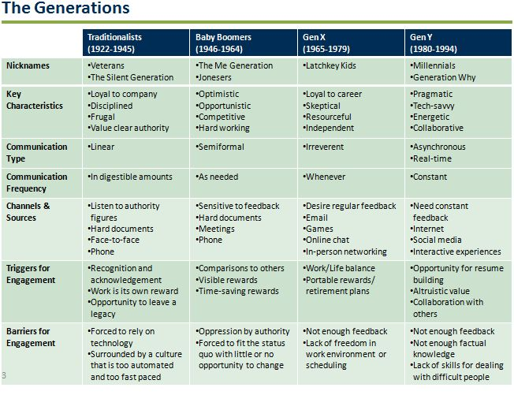
This text serves as a base for discussion about Ageism ( explanation?) and also about our perception of each age catergory.
Arriving at the eldery home, we invited a lady living there, who formely worked in a small seed enterprise and is visiting regulary the garden, as well as one of our older members of Transition Town. Both gave some input, such as a poem....
and talking about their life experience, difficulties they have with younger generations and so on.
Mixed with some tea/refreshments and some easy food, this ends in a lively exchange circle.

Needed:

Texts being printed enough for the participants
Some drinks and food like fruits, easy to carry
find beforehand older people who want to talk about their life experience
make contact with some eldery people home

Variations:

Visit other institutions, like schools, kindergarden and so on
Evaluate institutions via their appearance. Which needs are fulfilled here?
Try to organise a guided walk inside instirutions
Invite different care services for old people, like home care, family who cares about their eldest and so on, what are advantages, what are difficulties

Open Questions need to be researched ( also depending from the country)

How much does a space in a elderly people home costs, how much home services?
Which support is existing for family members to care for their elders ( like work hours reducing etc.)
what is a degrowth discourse on taking care for older people? Which are important texts/papers and authors on this topic?
How does the care debate interrelate the question about elderly people and children? Why are care taking people badly paid?

