Descriptive statistics GROWL course Witzenhausen

Number of participants: 7
Sex: 7 men (50%), 6 women (42,9%)
Mean all items: 3.00 (= great)
Standard deviation all items: .32

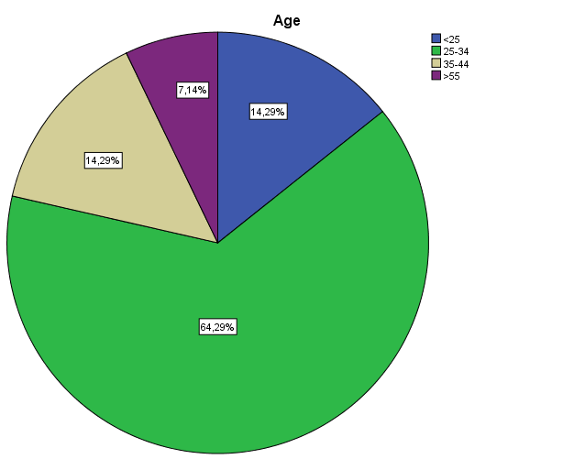

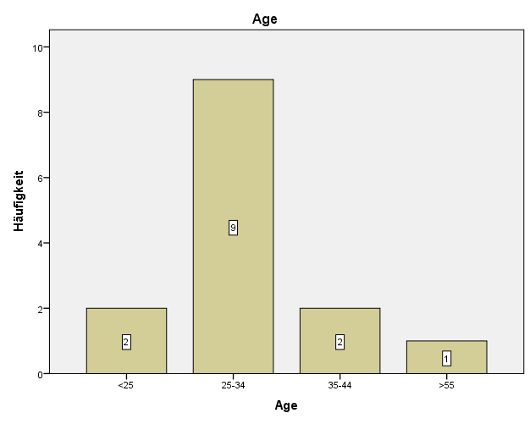

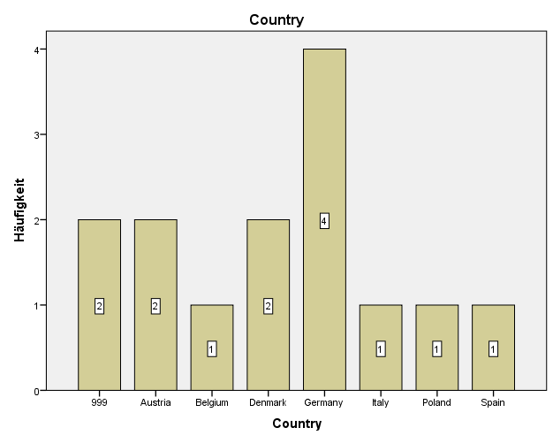

Descriptive statistics for questions asked

N = Number of participants who answered the item
Minimum = the lowest score of all participants on that item
Maximum = the highest score of all participants on that item

 | N | Minimum | Maximum | mean | Standard deviation
Degrowth_walk | 10 | 1 | 4 | 2,80 | 1,033
World_café_community_building | 11 | 2 | 4 | 2,82 | ,603
Approaching_the_sources_of_degrowth | 11 | 2 | 4 | 2,45 | ,820
Networking_globally_to_act_locally_building_communities | 7 | 1 | 4 | 2,29 | ,951
Folk_dance | 10 | 2 | 4 | 3,00 | ,816
Historical_and_critical_approach_to_communities | 11 | 2 | 4 | 3,27 | ,786
Transition_movment_introduction_and_critical_reflection | 10 | 1 | 4 | 2,50 | ,850
Contact_improvisation_and_transformation_of_society | 11 | 2 | 4 | 3,27 | ,786
Women_Men_circle_experience_exchange | 12 | 2 | 4 | 3,00 | ,739
Building_up_the_yurt_in_public_park | 11 | 2 | 4 | 3,27 | ,786
Introduction_to_Jurtenwesen_Building_yurts_for_buen_vivir | 10 | 2 | 4 | 2,90 | ,738
Singing_circle | 11 | 2 | 4 | 3,18 | ,603
Marketplace_and_cartography_of_projects | 10 | 2 | 4 | 3,50 | ,707
Reflective_working_experience | 10 | 2 | 4 | 3,50 | ,707
Drumming_circle_and_monochord_massage | 7 | 3 | 4 | 3,43 | ,535
Degrowth_party_in_students_club | 8 | 3 | 4 | 3,50 | ,535
Open_space | 10 | 1 | 4 | 2,60 | 1,075
Dancing_exploration | 7 | 2 | 4 | 3,29 | ,756
Contact_improvisation_workshop | 8 | 2 | 4 | 3,50 | ,756
Community_learning_and_intergerational_issues | 6 | 2 | 3 | 2,50 | ,548
Creative_degrowth_maniac_presentation | 3 | 2 | 2 | 2,00 | ,000
Public_debate_Economic_localisation_as_an_alternative | 7 | 2 | 3 | 2,29 | ,488
Closing_ritual | 7 | 2 | 4 | 3,43 | ,787
TTT_part_1 | 5 | 2 | 4 | 2,60 | ,894
TTT_part_2 | 4 | 2 | 4 | 2,50 | 1,000
Mornig_councils | 13 | 1 | 4 | 2,62 | 1,193
Maniac_Degrowth_reflection_of_the_day | 12 | 1 | 3 | 2,17 | ,718
Meals | 13 | 2 | 4 | 3,54 | ,660
Accomodation_in_the_Castle | 13 | 1 | 4 | 3,31 | 1,032
Accomodation_at_the_Town | 13 | 2 | 4 | 3,62 | ,650
seminar_spaces | 12 | 2 | 4 | 3,33 | ,651
Atmosphere | 12 | 3 | 4 | 3,33 | ,492
Group_dynamics_and_exchange | 13 | 2 | 4 | 3,31 | ,751
Overall_organisation | 12 | 1 | 4 | 2,58 | ,996
mean_all_items | 13 | 2,15 | 3,43 | 3,0044 | ,32199

How do you feel after the course?
Lost, relaxed; good, motivated to work; refreshed and in balance; interested; impressed by the program; full of ideas; good, happy, inspired; inspired, chaotic, net worked; inspired

Which inspiration do you take from the course with you?
community building; to be kind to everybody; transition houses; participative, active, constructive methodologies; a reminder of how important clear communication is; that is possible to organize real alternatives; community organization; empowerment, positive energy, community building knowledge

Further comments
it was perfect like it was; it was different and new; thanks for opening eyes and proving that degrowth is growing; maybe you should have scheduled some time into the day for writing the documentation; thanks; pedagogy for self-organisation was to be found in a new way: less preparation, more self-organisation

