Descriptive statistics GROWL course France

Number of participants: 13
Sex: 3 men (23,1%), 10 women (76,9%)
Mean all items: 3.19 (= great)
Standard deviation all items: 0.5

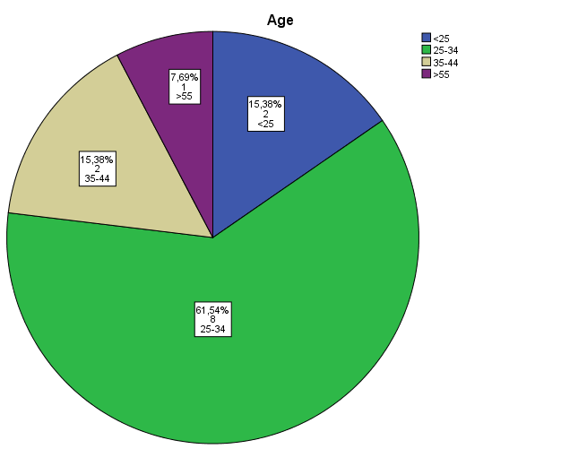

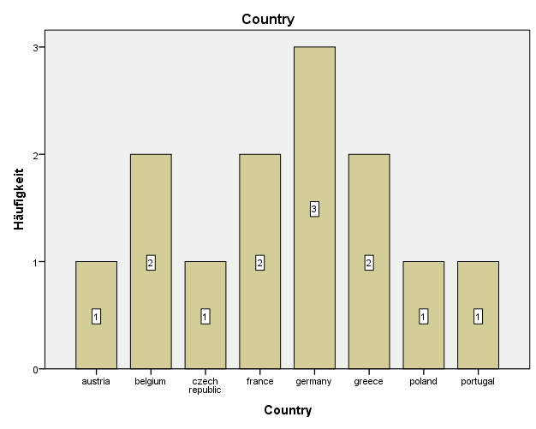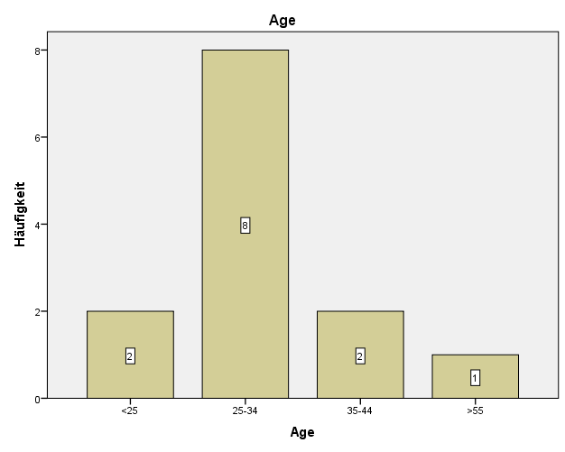

Descriptive statistics for questions asked

N = Number of participants who answered the item
Minimum = the lowest score of all participants on that item
Maximum = the highest score of all participants on that item

 | N | Minimum | Maximum | mean | Standard deviation
Weome_and_get_to_know_each_other | 13 | 2 | 4 | 3,54 | ,776
walter_benjamin | 11 | 1 | 4 | 2,55 | 1,293
forum_theater | 13 | 1 | 4 | 3,23 | 1,013
mapping_degrowth | 12 | 2 | 4 | 3,42 | ,793
jordi_pigem | 13 | 1 | 4 | 3,08 | 1,038
strategies | 11 | 2 | 4 | 3,45 | ,688
TTT_philosophy | 10 | 3 | 4 | 3,50 | ,527
TTT_organisational | 9 | 2 | 4 | 3,11 | ,782
TTT_political | 5 | 2 | 3 | 2,40 | ,548
working_groups | 4 | 3 | 4 | 3,75 | ,500
part_academic | 4 | 2 | 4 | 3,00 | 1,155
part_interactive | 4 | 3 | 4 | 3,75 | ,500
part_practical | 4 | 4 | 4 | 4,00 | ,000
part_poetic | 2 | 4 | 4 | 4,00 | ,000
part_political | 2 | 2 | 2 | 2,00 | ,000
folk_dance_party | 5 | 1 | 4 | 3,40 | 1,342
open_space | 1 | 3 | 3 | 3,00 | .
meals | 5 | 4 | 4 | 4,00 | ,000
accomodation | 5 | 3 | 4 | 3,80 | ,447
workshop_spaces | 4 | 3 | 4 | 3,75 | ,500
atmosphere | 5 | 2 | 4 | 3,60 | ,894
groups_dynamics | 5 | 2 | 4 | 2,80 | ,837
overall | 5 | 2 | 4 | 3,00 | 1,000

